Paper Title
First Author¹[0000-1111-2222-3333] and Second Author²[1111-2222-3333-4444]
¹ Princeton University, Princeton NJ 08544, USA
² Springer Heidelberg, Tiergartenstr. 17, 69121 Heidelberg, Germany
lncs@springer.com
Abstract. The abstract should summarize the contents of the paper in short terms, i.e. 150-250 words.
Keywords: First Keyword, Second Keyword, Third Keyword.
- First Section
  - A Subsection Sample
Please note that the first paragraph of a section or subsection is not indented. The first paragraphs that follows a table, figure, equation etc. does not have an indent, either.
Subsequent paragraphs, however, are indented.

Sample Heading (Third Level). Only two levels of headings should be numbered. Lower level headings remain unnumbered; they are formatted as run-in headings.

Sample Heading (Forth Level). The contribution should contain no more than four levels of headings. The following Table 1 gives a summary of all heading levels.
Table 1. Table captions should be placed above the tables.
Heading level | Example | Font size and style
Title (centered) | Lecture Notes | 14 point, bold
1st-level heading | 1 Introduction | 12 point, bold
2nd-level heading | 2.1 Printing Area | 10 point, bold
3rd-level heading | Run-in Heading in Bold. Text follows | 10 point, bold
4th-level heading | Lowest Level Heading. Text follows | 10 point, italic
Displayed equations are centered and set on a separate line.
x + y = z (1)
Please try to avoid rasterized images for line-art diagrams and schemas. Whenever possible, use vector graphics instead (see Fig. 1).
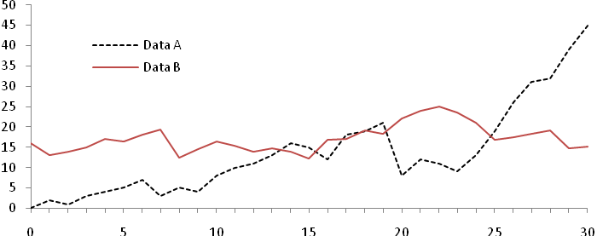
Fig. 1. A figure caption is always placed below the illustration. Short captions are centered, while long ones are justified. The macro button chooses the correct format automatically.
For citations of references, we prefer the use of square brackets and consecutive numbers. Citations using labels or the author/year convention are also acceptable. The following bibliography provides a sample reference list with entries for journal articles [1], an LNCS chapter [2], a book [3], proceedings without editors [4], as well as a URL [5].

The number of pages in a paper shall be not less than 4 and limited to maximum of 12 pages, including all tables and figures. The pages shall have a different first page and pages are to be numbered are as given in template. The footer shall have paper number to the left and page number to the right.

In references section, the Journal/ Conference title shall be given in Title Case. Also, the name of the publisher of a book shall be in Title Case

References
- Author, F.: Article title. Journal 2(5), 99–110 (2016).
- Author, F., Author, S.: Title of a proceedings paper. In: Editor, F., Editor, S. (eds.) CONFERENCE 2016, LNCS, vol. 9999, pp. 1–13. Springer, Heidelberg (2016).
- Author, F., Author, S., Author, T.: Book title. 2nd edn. Publisher, Location (1999).
- Author, F.: Contribution title. In: 9th International Proceedings on Proceedings, pp. 1–2. Publisher, Location (2010).
- IS 2720-Part 8: Methods of test for soils – Determination of water content - dry density relation, Bureau of Indian Standards, New Delhi (1983).
- LNCS Homepage, http://www.springer.com/lncs, last accessed 2016/11/21.

